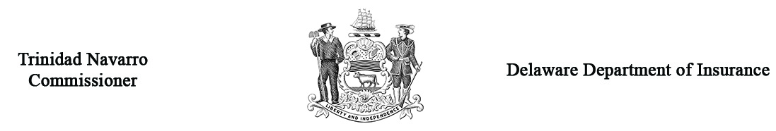

Automobile Arbitration Respondent’s Answer
Applicant’s Name |  |  |  |  |  |  | Arbitration Case #  (Office Use only)
Name of Respondent Company
Address
Email Address
Respondent’s Policyholder
Address
Policy # |  |  |  |  |  | Claim #
Representative |  |  |  |  |  | Phone #
Adjuster’s License # |  |  |  | Respondent Company NAIC #
Do you admit coverage? |  |  | yes no | Do you admit liability? |  |  |  |  |  | yes no
Has settlement been attempted? |  |  | yes no
Has an offer been made? |  |  | yes no
If offer has been made, indicate the amount: |  |  |  |  |  |  |  | Damage to Auto
 |  |  |  |  |  |  |  | Loss of Use
 |  |  |  |  |  |  |  | Payment Under PIP
Who will represent your company at the hearing? |  |  |  | Email:
Should a Co-Respondent be named; if so, identify: |  |  |  | yes no
Name
Address
Insurance Company
State your answer to the complaint filed by the applicant

WITNESS: Controverting parties may present witnesses in their behalf provided due notice is given. If you wish to present witnesses; list name, address and telephone number on a separate sheet; submit one (1) copy and attach to this form. Witnesses not listed will not be admitted.

________________________________________________________________ __________________________
Signature – Respondent’s Representative Date

Return one (1) copy to: Delaware Insurance Department
1351 West North St., Ste. 101, Dover, DE 19904

Note: You must forward a copy of all documentation to be used at the hearing to the opposing party
at least 5 business days prior to hearing date (Regulation 901, Section 10.4).

