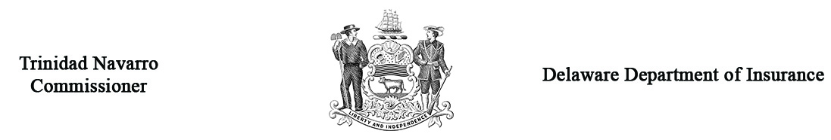

Regulation 1315 – Form B
Response to Petition for Health Insurance Arbitration
Arbitration Case # __________
(Office Use Only)
Claimant’s Name
Address
Policyholder Information (if different from Claimant)
Name
Address

Respondent Information
Name
Address
Phone # |  |  |  |  |  |  |  |  |  |  | NAIC #:
If the petition relates to the services of an individual physician, include the following information:
Physician’s Name and Practice Group
Address
Phone #
Policy #
Claim # Assigned by Respondent
Date of Determination of  Independent Review Process (IRP) |  |  |  |  | Amount of Claim Admitted by Respondent |  |  |  |  |  |  |  | $
Dates of Service |  | (From) |  |  |  |  |  | (To)
Briefly describe the basis for your response/objection to the petition and attach the notification or explanation of benefits
you provided to the claimant. (If needed, attach separate sheet.)
Prior to the hearing, it is necessary that you submit the appropriate documents to support your petition to the Delaware Insurance Department and to the opposing party.

Parties may present witnesses on their behalf at the hearing provided that due notice is given. Please list the name, address and telephone number of all witnesses you expect to appear on your behalf on a separate sheet and attach it to this form.
If a settlement has been offered to you, how much was it: |  |  |  | $
Who will represent you at the hearing? | Self Attorney
Address
Phone #

Under Delaware Law, any person who knowingly, and with intent to injure, defraud, or deceive any insurer who files a statement or claim containing any false, incomplete, or misleading information is guilty of a felony

_________________________________________________________________ __________________________
Signature – Respondent’s Representative Date

Return four (4) copies to: Insurance Commissioner, Delaware Insurance Department
1351 West North Street, Suite 101, Dover, DE 19904

