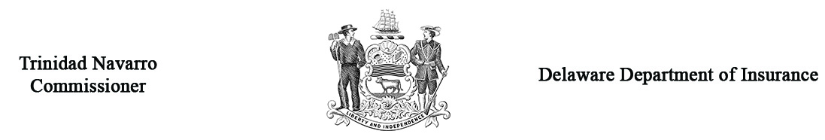

Regulation 1315 - Form A
Petition for Health Insurance Arbitration
Arbitration Case # ___________
(Office use only)
Your Name
Your Address
Your Phone #
Were you: | Patient Spouse Parent or Guardian Power of Attorney Other
Name of the Insurance Co. against which you are making a claim |  |  |  |  |  |  |  | NAIC #
Address
Phone #
Name of the Policyholder
(if other than you)
Address (if different from above)
Date of determination of  Independent Review Process (IRP) |  |  |  | Amount of your claim |  |  | $
Dates of Service |  | (From) |  |  | (To)
Briefly describe the basis for your claim and attach the notification or explanation of benefits you received from the Insurance Company
(If needed, attach separate sheet.)

IMPORTANT * The petition will not be accepted without the filing fee included. It is necessary that you submit 2 copies of all documentation to support your claim prior to the hearing. You are required to submit one copy to the opposing party prior to the hearing.

Parties may present witnesses in their behalf at the hearing provided that due notice is given. Please list the name, address and telephone number of all witnesses you expect to appear on your behalf on a separate sheet and attach it to this form.

If a settlement has been offered to you, how much was it: | $

Who will represent you at the hearing? Self Attorney ________________________________________________
Name
Address
Phone #

Under Delaware Law, any person who knowingly, and with intent to injure, defraud, or deceive any insurer who files a statement or claim containing any false, incomplete, or misleading information is guilty of a felony.

_____________________________________________________ __________________________
Your Signature Date

Return the original and three (3) copies to: Insurance Commissioner, Delaware Insurance Department
841 Silver Lake Blvd., Dover, DE 19904

Note: You must forward a copy of all documentation to be used at the hearing to the opposing party at least 5 business days prior to hearing date.

