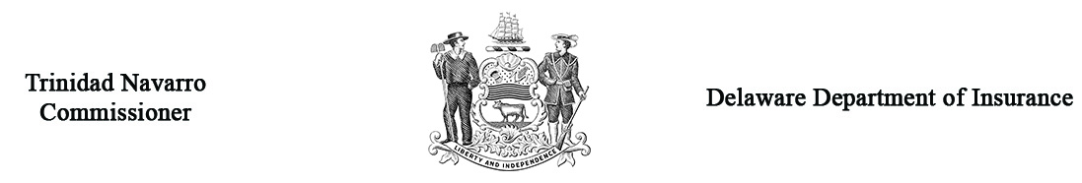

Request for Homeowners’ Arbitration

Name |  |  |  |  |  |  | Arbitration Case #  (Office Use Only)
Address
Home Phone # |  |  |  |  | Work Phone #
Name of Insurance Company against which you are making a claim |  |  |  |  |  |  |  |  |  | NAIC#
Insurance Company Address
Name of Adjuster
Claim # |  |  |  |  |  | Policy #
Date of Damage
Describe how the damage occurred
(If needed, attach separate sheet.)
IMPORTANT * The petition will not be accepted without the filing fee included. It is necessary that you submit 4 copies of all documentation to support your claim prior to the hearing. You are required to submit one copy to the opposing party at least 5 days prior to the hearing.

Amount of damage you are asking for? |  |  | $
If settlement has been offered, how much was it?  (You must indicate) |  |  | $
Who will represent you at the hearing? |  | Self Attorney |  |  |  | (name)
Attorney’s Address___________________________________________
___________________________________________
Attorney’s Phone #___________________________________________

WITNESS: Controverting parties may present witnesses on their behalf provided due notice is given. If you wish to present witnesses; list name, address and telephone number on a separate sheet; submit (4) copies (one used for interoffice and three used for the Panel members) and attach to this form. Witnesses not listed will not be admitted.

Under Delaware Law, any person who knowingly, and with intent to injure, defraud, or deceive any insurer who files a statement or claim containing any false, incomplete or misleading information is guilty of a felony.

_________________________________________________________________ __________________________
Your Signature Date

Return four (4) copies to: Insurance Commissioner, Delaware Insurance Department
841 Silver Lake Blvd.
Dover, DE 19904

Note: You must forward a copy of all documentation to be used at the hearing to the opposing party
at least 5 business days prior to hearing date (Regulation 901, Section 10.4).

