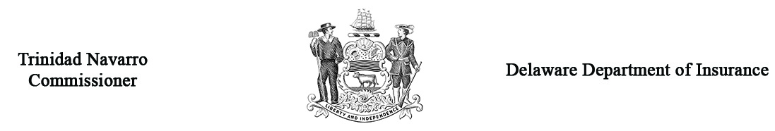

Regulation 1319 – Form B
Response to Petition for Primary Care and Chronic Care Management Services Reimbursement Arbitration

Arbitration Case # _______________
(Office use only)
Respondent Company Name
Respondent Address
Respondent Phone #
Claimant Name
Claimant Practice Group
Claimant Address
Provider Phone #
Name of Policyholder
Policyholder Address
Date of determination of claim
Dates of Service | From: |  | To:
Amount of claim paid by Respondent | $
Briefly describe the basis for your response/objection to the Petition indicating each CPT Code in dispute and attach the notification or explanation that you sent to the claimant.
(If needed, attach separate sheet)
Prior to the hearing, it is necessary that you submit the appropriate documents to support your Response to Petition to the Delaware Department of Insurance and to the Claimant.

Parties may present witnesses on their behalf at the hearing provided that due notice is given. Please list the name, address, and telephone number of all witnesses you expect to appear on your behalf on a separate sheet and attach it to this form.

If you have made a settlement offer, how much was it? $___________________

Who will represent you at the hearing? _______ Self ________ Attorney
If an attorney will represent you, please provide the following:
Name: _________________________________ Address: ____________________________________________________________
Phone #: _______________________________

Under Delaware law, any person who knowingly, and with intent to injure, defraud, or deceive any insurer files a statement or claim containing false, incomplete, or misleading information is guilty of a felony.

___________________________________________________ __________________________________
Signature of Respondent’s Representative Date

Return the original and one (1) copies of this Response to Petition to: | Arbitration Secretary  Delaware Department of Insurance  841 Silver Lake Boulevard  Dover, DE 19904
Note: You must also send a copy of this Response to Petition to the Complainant by first class mail, postage prepaid. Use Form C to provide confirmation to the Department that a copy of this Petition was sent to the Complainant. (Forms are available at www.insurance.delaware.gov.)

