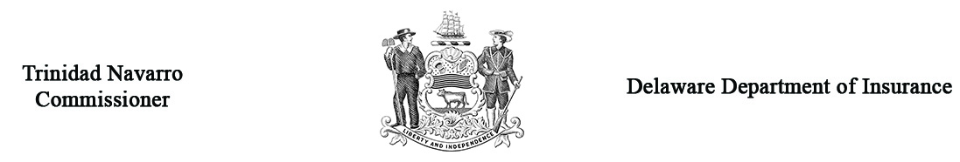

Regulation 1319 – Form A
Petition for Primary Care and Chronic Care Management Services Reimbursement Arbitration

Arbitration Case # _______________
(Office use only)
Claimant Name
Claimant Type (Out or in-network AND specialty provider type (SPT)) | __Out __In (check one) SPT:
Claimant Address
Work Phone #
Name of insurance company against which you are making a claim
Insurance company address
Insurance company phone #
Name of Policyholder
Policyholder Address
Policy #
Is the plan an SB 227-qualifying plan? (check one) ____ yes, it’s a qualifying individual plan, __ yes, it’s a qualifying group plan, ___ no or I don’t know.
Was the policyholder: _____ Patient _____ Spouse ______ Parent or guardian ____ Power of attorney ____ Other
Date of determination of claim
Amount of your claim | $
Dates of Service | From: |  | To:
Describe the basis for your claim, including the individual CPT Codes in dispute and attach the notification or explanation that you received from the insurance company (attach additional sheets as necessary).
Prior to the hearing, you MUST submit the appropriate documents to support your Petition to the Delaware Department of Insurance and to the opposing party.

Parties may present witnesses on their behalf at the hearing, provided that due notice is given. Please list the name, address, and telephone number of all witnesses you expect to appear on your behalf on a separate sheet and attach it to this form.

If a settlement has been offered to you, how much was it? $___________________

Who will represent you at the hearing? _______ Self _______ Attorney
If an attorney will represent you, please provide the following:
Name: _________________________________ Address: ____________________________________________________________
Phone #: _______________________________

Under Delaware law, any person who knowingly, and with intent to injure, defraud, or deceive any insurer files a statement or claim containing false, incomplete, or misleading information is guilty of a felony.

___________________________________________________ __________________________________
Your Signature Date
Note: In addition to submitting this form to the Department of Insurance, you must also send a copy of this Petition to the insurance company by certified mail, return receipt requested. Use Form C to provide confirmation to the Department that a copy of this Petition was sent to the insurance company. (Forms are available at www.insurance.delaware.gov/services/arbitration.)
Filing Fee: There is a non-refundable filing fee of $75 per date of service. Please enclose a check made payable to the Delaware Department of Insurance.
For the insurance company recipient: Within 20 days of receiving this Petition, you must return a Form B Response to Petition and one (1) copy to: | Arbitration Secretary  Delaware Department of Insurance  841 Silver Lake Boulevard  Dover, DE 19904

Individual health insurance policy issued under 18 Del. C. § 3342A
Group health insurance policy issued under 18 Del. C. § 3556A

