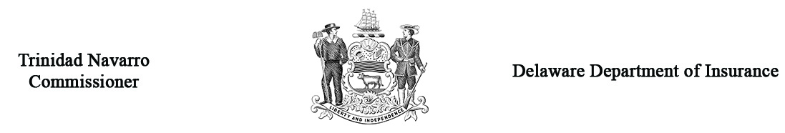

Request for Automobile Arbitration

Name |  |  |  |  |  |  |  |  |  |  |  |  | Arbitration Case #  (Office Use Only)
Address
Home Phone # |  |  |  |  |  |  |  |  |  |  |  | Work Phone #
Name of Insurance Company against which you are making a claim |  |  |  |  | NAIC#
Insurance Company Address
Name of the Policyholder
Policyholder Address
Were you: |  | Driver of the Car Involved |  |  |  |  |  |  |  | Owner of the Car Involved |  |  |  |  |  | Pedestrian |  | Passenger
If you were not the owner of the car in which you were riding or driving, who was the owner?
Their Address
Their Phone #
Claim # |  |  |  |  |  |  |  |  |  |  |  |  | Policy #
Name of Adjuster
Date of Accident |  |  |  |  |  |  | Place of Accident
Describe how the loss occurred with a brief statement of your complaint. If needed, attach separate sheet.
The complaint for which you are asking the panel to rule on involves:
Physical Damage Loss of Use Personal Injury Protection (PIP) Medical Bills, Lost Wages, Substitute Services/Death Benefits
*Amount of Damage you are asking for: (must indicate amount)
Amount of physical damage? |  |  |  | $ |  |  |  |  |  |  | Amount of Loss of Use |  |  |  |  |  |  |  |  | $
Amount of Medicals/Lost Wages |  |  |  | $ |  |  |  |  |  |  | Amount of Substitute Service |  |  |  |  |  |  |  |  | $
Amount of Death Benefits |  |  |  | $ |  |  |  |  |  |  | Percentage of Negligent Damages Accessed  (If applicable) |  |  |  |  |  |  |  |  | %
IMPORTANT * The petition will not be accepted without the filing fee included. It is necessary that you submit 4 copies of all documentation to support your claim prior to the hearing. You are required to submit one copy to the opposing party prior to the hearing.
If settlement has been offered, how much was it? (You must indicate) |  |  |  |  |  |  |  |  |  |  |  |  | $
Who will represent you at the hearing? |  |  |  |  |  | Self Attorney
 |  |  |  |  |  | Address
 |  |  |  |  |  | Phone #

WITNESS: Controverting parties may present witnesses on their behalf provided due notice is given. If you wish to present witnesses; list name, address and telephone number on a separate sheet; submit (4) copies (one used for interoffice and three used for the Panel members) and attach to this form. Witnesses not listed will not be admitted.

Under Delaware Law, any person who knowingly, and with intent to injure, defraud, or deceive any insurer who files a statement or claim containing any false, incomplete or misleading information is guilty of a felony.

_________________________________________________________________ __________________________
Your Signature Date

Return four (4) copies to: Insurance Commissioner, Delaware Insurance Department
1351 West North Street, Suite 101
Dover, DE 19904

Note: You must forward a copy of all documentation to be used at the hearing to the opposing party
at least 5 business days prior to hearing date (Regulation 901, Section 10.4).

